**TAMILNADU STATE COUNCIL FOR SCIENCE AND TECHNOLOGY**

**DOTE Campus, Chennai-600025**

**STUDENT PROJECTS SCHEME**

1. **Name of the Student (s):** Vijaya Gokul K, Raja Subramanian V

**E-mail id:** [vijayagokulkumaran_cs@mepcoeng.ac.in](mailto:vijayagokulkumaran_cs@mepcoeng.ac.in) , [vel.yudham_cs@mepcoeng.ac.in](mailto:vel.yudham_cs@mepcoeng.ac.in)

1. **Name of the Guide :** Dr. B. Lakshmanan

**Department / Designation:** Associate Professor, Department of Computer Science and Engineering

**Institutional Address:** Mepco Schlenk Engineering College, Mepco Nagar, Sivakasi

**Phone No & Mobile No**: 04562-235361, 9944520528

1. **Project Title:** Automated Computer Vision Based Deep Framework for Breast Mass Detection in Mammography Images
2. **Sector in which your Project proposal is to be considered:** Computer Science and Engineering.
3. **Project Details:**
4. **Introduction**

Breast cancer is the most common cancer among women, accounting for 25.4% of all new cancer cases in 2023. Early detection is essential for improving mortality rates, and mammography is the primary screening tool for breast cancer. However, mammography interpretation is challenging, and even experienced radiologists can miss subtle lesions.

Deep learning has the potential to improve the accuracy of breast cancer detection and segmentation in mammography images. Deep learning models can be trained to learn the features of breast masses and other abnormalities, and to distinguish between benign and malignant lesions. Deep learning models can be used to segment breast masses, which can help radiologists to better visualize and characterize the lesions.

YOLOv8 and DeepLabv3 are two state-of-the-art deep learning models for object detection and segmentation, respectively. YOLOv8 is a fast and accurate object detector that has been shown to achieve high performance on a variety of tasks, including breast mass detection. DeepLabv3 is a powerful segmentation model that has been shown to achieve high performance on a variety of medical image segmentation tasks, including breast mass segmentation. In this proposed work, we adopt to model with light weight architecture to perform accurate detection of mass with less computational time.

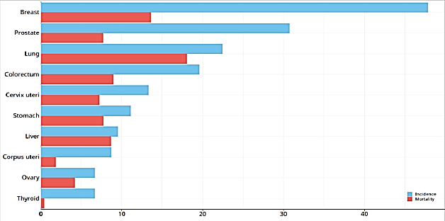

**Figure 1: Global age-standardized incidence rates of breast cancer,**

Figure 1 shows the age-standardized incidence rates of breast cancer that have increased over time. The increase is due to various factors, including population aging, increased urbanization, and changes in lifestyle.

1. **Motivation**

Breast cancer is the most common cancer among women worldwide, and it is the leading cause of cancer death among women in developing countries. Early detection and treatment of breast cancer is essential for improving survival rates.

Mammography is the primary screening tool for breast cancer. However, mammography can be difficult to interpret, and radiologists often miss breast cancers. This is especially true for women with dense breasts or with small breast cancers. To develop a model that detects any range, mammograph image with huge noise.

The motivation of the study is to develop fast, accurate and reliable systems that can help radiologists to better diagnose breast cancer.

The study of breast mass detection and segmentation is also motivated by the need to develop systems that are accessible and affordable to women in all parts of the world.

1. **Objectives**

* To develop a light weight deep learning model that can accurately detect and segment breast masses in mammography images.
* To improve the robustness of the model to noise and variability in image quality.
* To achieve better performance than existing methods on a held-out test set.

1. **Methodology**

The proposed method will be developed using a combination of deep learning techniques, including:

1. **YOLOv8** used for breast mass detection.
2. **DeepLabv3** used for breast mass segmentation.

The proposed method uses **CBIS-DDSM** and **INbreast** datasets.

**Table 1: Dataset Description of CBIS-DDSM & INbreast Dataset**

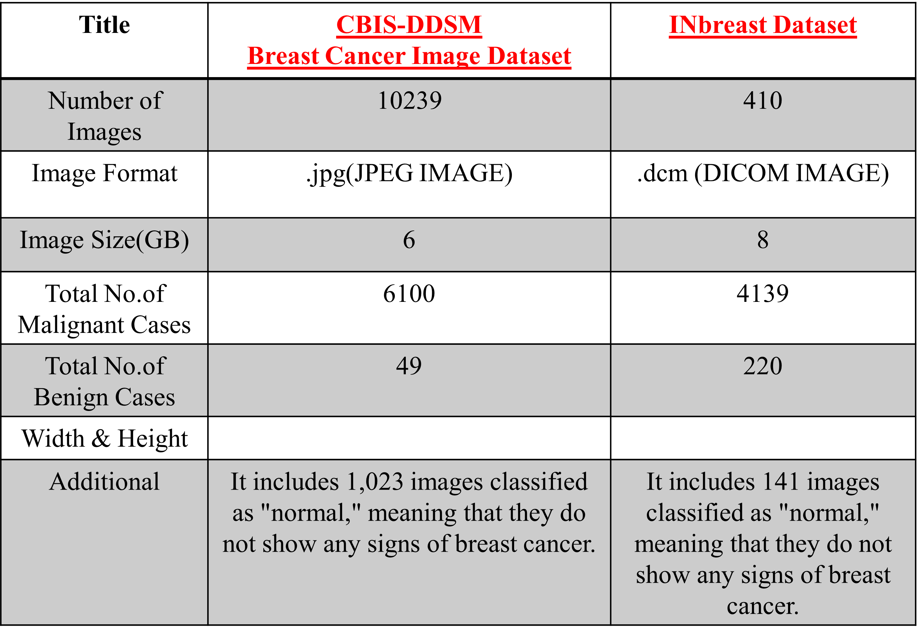

Table1 shows a detailed description of the CBIS-DDSM & INbreast Dataset. It gives the Number of Images, Number of Malignant and Benign Cases in the dataset.

The training dataset will be divided into three parts:

* Training set
* Validation set
* Test set

The training set will be used to train the model, the validation set will be used to evaluate the performance of the model during training, and the test set will be used to evaluate the performance of the model after training. The proposed method will be evaluated using a variety of metrics, including accuracy, sensitivity, and specificity for detection, and dice coefficient and mean IoU ( Intersection over Union ) for segmentation.

The modules involved in a computer vision-based system are:

* Data Collection from Clinic trial(Realtime Data)
* Data Preprocessing
* Breast Mass Detection
* Mass Segmentation
* Visualization using IBM Cognos Analytics
* Evaluation / Validation of results

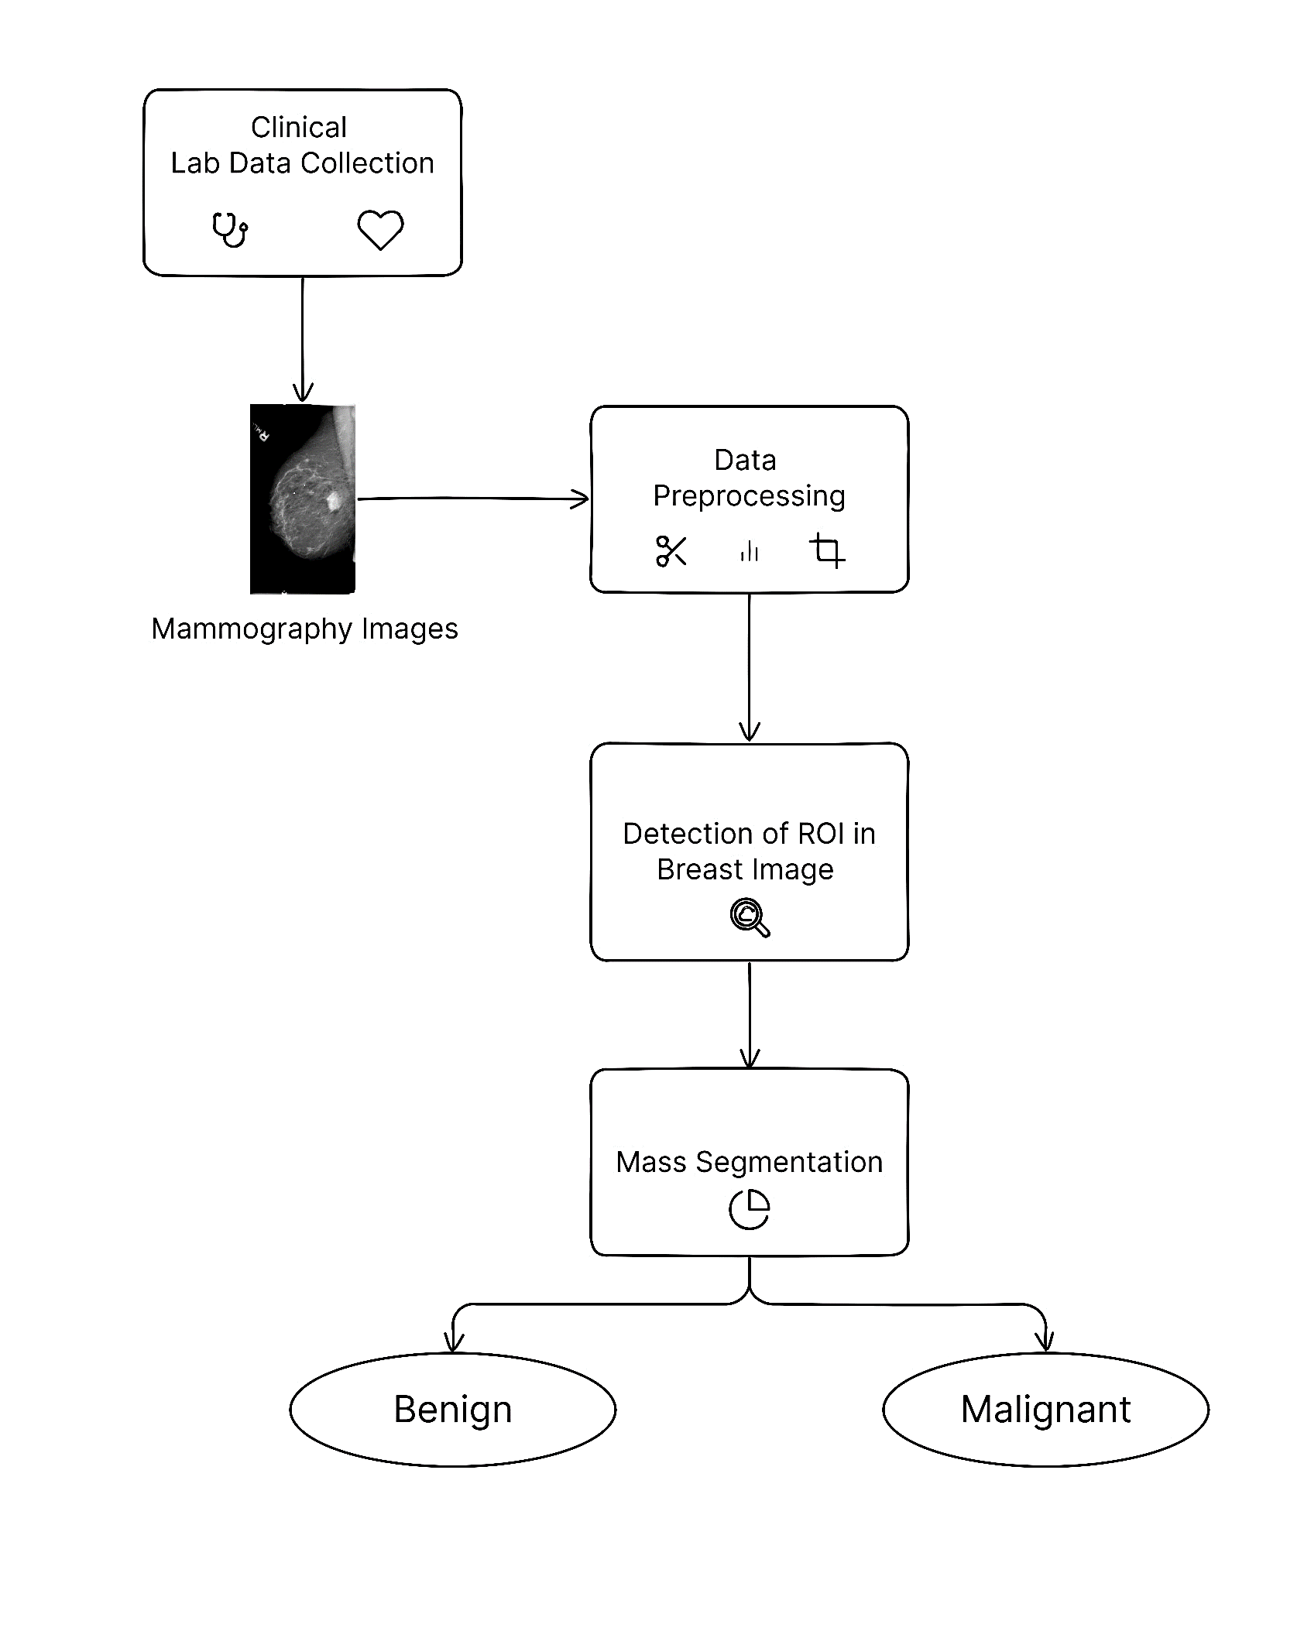

**Figure 2: System Design Diagram of the Proposed System**

Figure 2 describes about the process starting with collection of mammographic images. The images are then pre-processed, followed by the detection of region of interest (ROI) in the breast image. The ROI is then segmented into mass and benign tissue. Finally, the mass is classified as malignant or benign..

1. **Work Plan**

|  |  |  |  |  |
| --- | --- | --- | --- | --- |
| **Activity** | **Months** | | | |
| 1 | 2 | 3 | 4 |
| Data Collection |  |  |  |  |
| Preparation of Dataset |  |  |  |  |
| Data Preprocessing |  |  |  |  |
| Computer Vision Model Development |  |  |  |  |
| Model Evaluation & Deployment at fields |  |  |  |  |
| Lab trails |  |  |  |  |
| Seminar presentation & Report generation |  |  |  |  |

1. **Budget**

|  |  |  |
| --- | --- | --- |
| **S. No** | **Components Details** | **Approximate Cost in (Rs.)** |
| 1. | IBM Cognos Analytics | 4,500 |
| 2. | Lab / Field trails expenses | 3,500 |
| **3.** | Attending seminar presentation /conference | 4,000 |
| **Total Amount** | | 12,000 |

*IBM Cognos Analytics – For a period of 1 Year.